**Hands on 1**

**Create a Spring Web Project using Maven**

**Creating Spring Web Project:**

**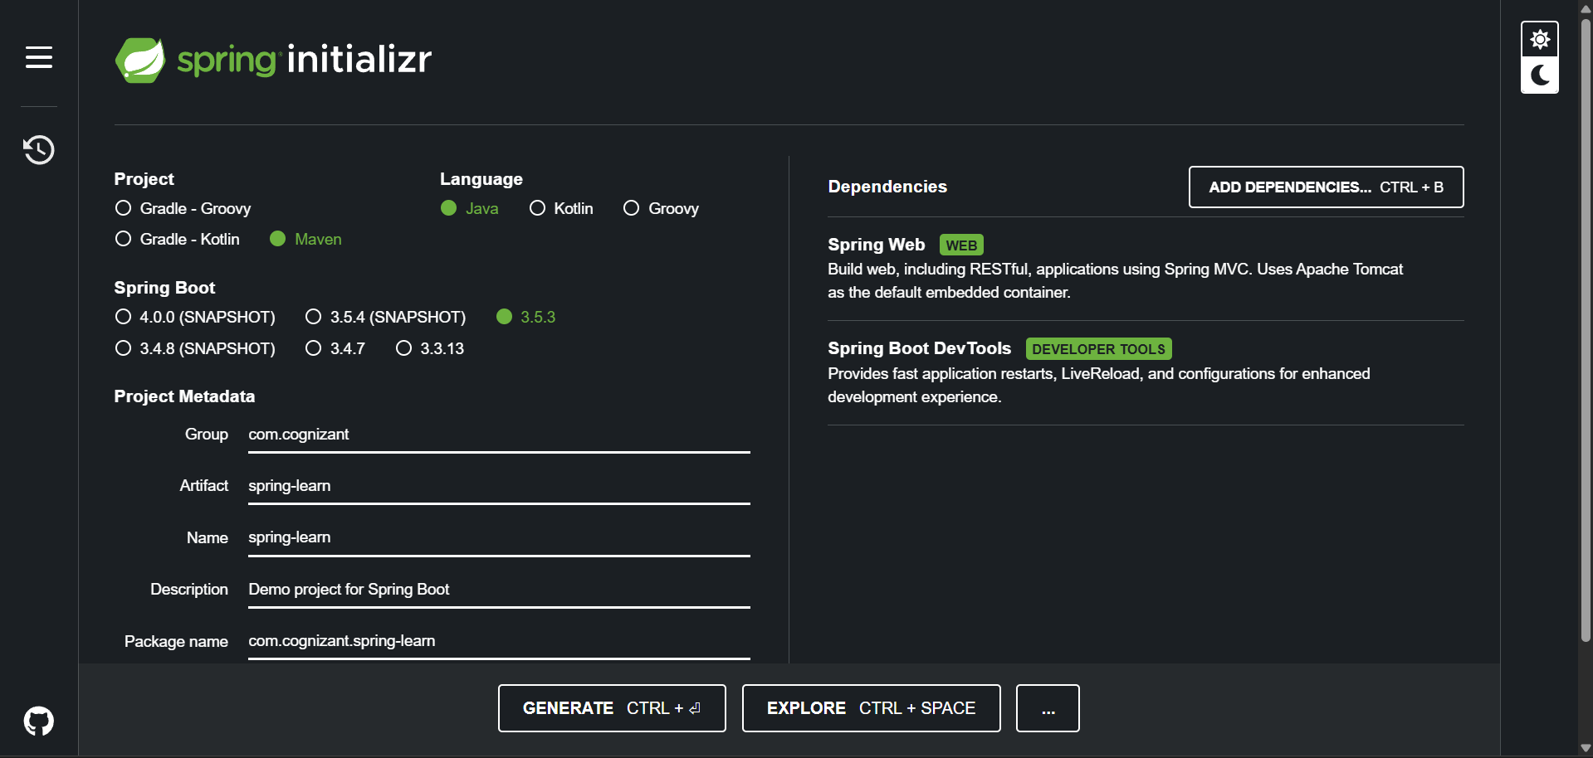  
  
SpringLearnApplication.java**

package com.cognizant.spring_learn;  
  
import org.springframework.boot.SpringApplication;  
import org.springframework.boot.autoconfigure.SpringBootApplication;  
  
@SpringBootApplication  
public class SpringLearnApplication {  
  
 public static void main(String[] args) {  
 SpringApplication.*run*(SpringLearnApplication.class, args);  
 System.*out*.println("SpringLearnApplication Started");  
 }  
  
}

**Pom.xml:**

<?xml version="1.0" encoding="UTF-8"?>  
<project xmlns="http://maven.apache.org/POM/4.0.0" xmlns:xsi="http://www.w3.org/2001/XMLSchema-instance"  
 xsi:schemaLocation="http://maven.apache.org/POM/4.0.0 https://maven.apache.org/xsd/maven-4.0.0.xsd">  
 <modelVersion>4.0.0</modelVersion>  
 <parent>  
 <groupId>org.springframework.boot</groupId>  
 <artifactId>spring-boot-starter-parent</artifactId>  
 <version>3.5.3</version>  
 <relativePath/> <!-- lookup parent from repository -->  
 </parent>  
 <groupId>com.cognizant</groupId>  
 <artifactId>spring-learn</artifactId>  
 <version>0.0.1-SNAPSHOT</version>  
 <name>spring-learn</name>  
 <description>Demo project for Spring Boot</description>  
 <url/>  
 <licenses>  
 <license/>  
 </licenses>  
 <developers>  
 <developer/>  
 </developers>  
 <scm>  
 <connection/>  
 <developerConnection/>  
 <tag/>  
 <url/>  
 </scm>  
 <properties>  
 <java.version>21</java.version>  
 </properties>  
 <dependencies>  
 <dependency>  
 <groupId>org.springframework.boot</groupId>  
 <artifactId>spring-boot-starter-web</artifactId>  
 </dependency>  
  
 <dependency>  
 <groupId>org.springframework.boot</groupId>  
 <artifactId>spring-boot-devtools</artifactId>  
 <scope>runtime</scope>  
 <optional>true</optional>  
 </dependency>  
 <dependency>  
 <groupId>org.springframework.boot</groupId>  
 <artifactId>spring-boot-starter-test</artifactId>  
 <scope>test</scope>  
 </dependency>  
 </dependencies>  
  
 <build>  
 <plugins>  
 <plugin>  
 <groupId>org.springframework.boot</groupId>  
 <artifactId>spring-boot-maven-plugin</artifactId>  
 </plugin>  
 </plugins>  
 </build>  
  
</project>

**@SpringBootApplication Annotation:**

@SpringBootApplication is a convenience annotation that combines @Configuration, @EnableAutoConfiguration, and @ComponentScan to enable auto-configuration, component scanning, and Java-based configuration in a Spring Boot application.

**Dependency Hierarchy:**

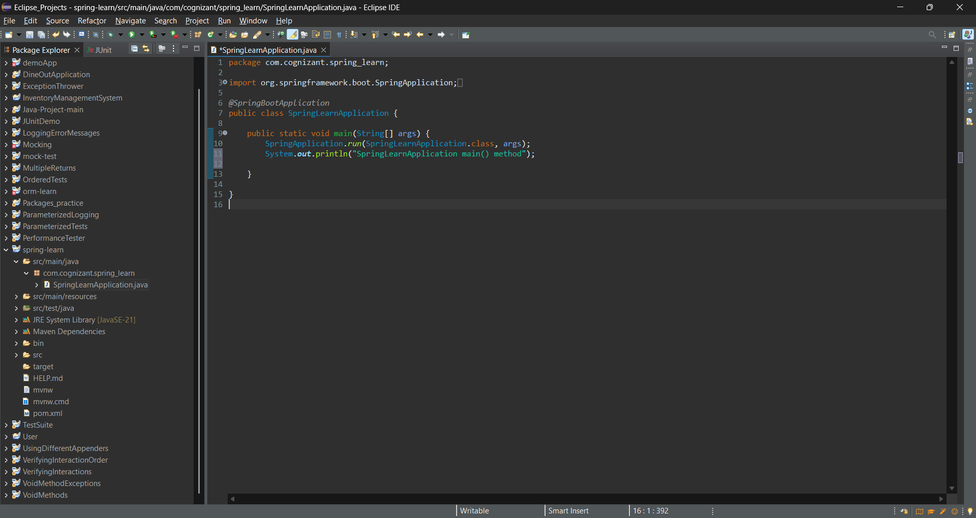

**Output:**

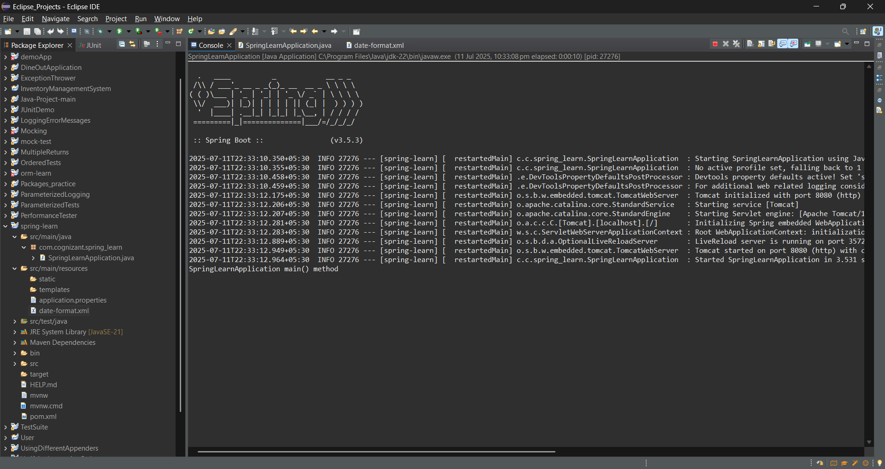

**Hands on 2**

Spring Core – Load SimpleDateFormat from Spring Configuration XML   
  
**date-format.xml**

<?xml version="1.0" encoding="UTF-8"?>

<beans xmlns="http://www.springframework.org/schema/beans"

xmlns:xsi="http://www.w3.org/2001/XMLSchema-instance"

xsi:schemaLocation="http://www.springframework.org/schema/beans

https://www.springframework.org/schema/beans/spring-beans.xsd">

<bean id="dateFormat" class="java.text.SimpleDateFormat">

<constructor-arg value="dd/MM/yyyy" />

</bean>

</beans>

**SpringLearnApplication.java**

package com.cognizant.spring_learn;

import java.text.ParseException;

import java.text.SimpleDateFormat;

import java.util.Date;

import org.springframework.boot.SpringApplication;

import org.springframework.boot.autoconfigure.SpringBootApplication;

import org.springframework.context.ApplicationContext;

import org.springframework.context.support.ClassPathXmlApplicationContext;

*@SpringBootApplication*

public class SpringLearnApplication {

public static void main(String[] args) {

SpringApplication.*run*(SpringLearnApplication.class, args);

System.***out***.println("SpringLearnApplication main() method");

*displayDate*();

}

public static void displayDate() {

ApplicationContext context = new ClassPathXmlApplicationContext("date-format.xml");

SimpleDateFormat format = context.getBean("dateFormat", SimpleDateFormat.class);

try {

Date date = format.parse("31/12/2018");

System.***out***.println("Parsed Date: " + date);

} catch (ParseException e) {

e.printStackTrace();

}

}

}

Output:

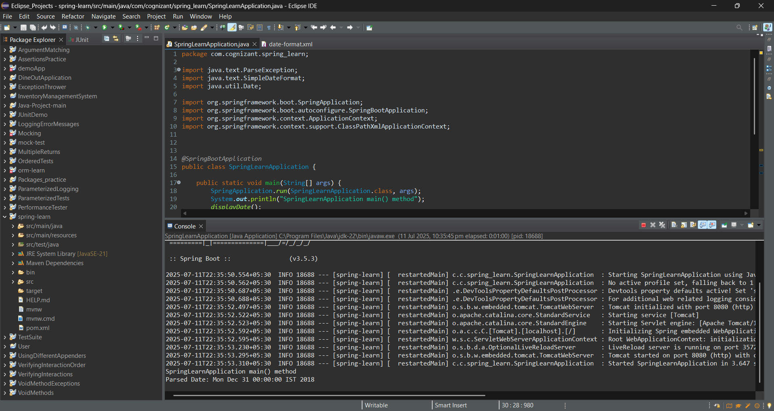

**Hands on 3**

**Spring Core - Incorporate Logging**   
  
**SpringLearnApplication.java**

package com.cognizant.spring_learn;

import java.text.ParseException;

import java.text.SimpleDateFormat;

import java.util.Date;

import org.springframework.boot.SpringApplication;

import org.springframework.boot.autoconfigure.SpringBootApplication;

import org.springframework.context.ApplicationContext;

import org.springframework.context.support.ClassPathXmlApplicationContext;

import org.slf4j.Logger;

import org.slf4j.LoggerFactory;

*@SpringBootApplication*

public class SpringLearnApplication {

private static final Logger ***LOGGER*** = LoggerFactory.*getLogger*(SpringLearnApplication.class);

public static void main(String[] args) {

SpringApplication.*run*(SpringLearnApplication.class, args);

***LOGGER***.info("SpringLearnApplication main() method");

*displayDate*();

}

public static void displayDate() {

***LOGGER***.info("START");

ApplicationContext context = new ClassPathXmlApplicationContext("date-format.xml");

SimpleDateFormat format = context.getBean("dateFormat", SimpleDateFormat.class);

try {

Date date = format.parse("31/12/2018");

***LOGGER***.debug("Parsed Date: {}", date);

} catch (ParseException e) {

e.printStackTrace();

}

***LOGGER***.info("END");

}

}

**Application.properties**

spring.application.name=spring-learn

logging.level.org.springframework=info

logging.level.com.cognizant.springlearn=debug

logging.pattern.console=%d{yyMMdd}|%d{HH:mm:ss.SSS}|%-20.20thread|%5p|%-25.25logger**{25}**|%25M|%m%n

**Output:**

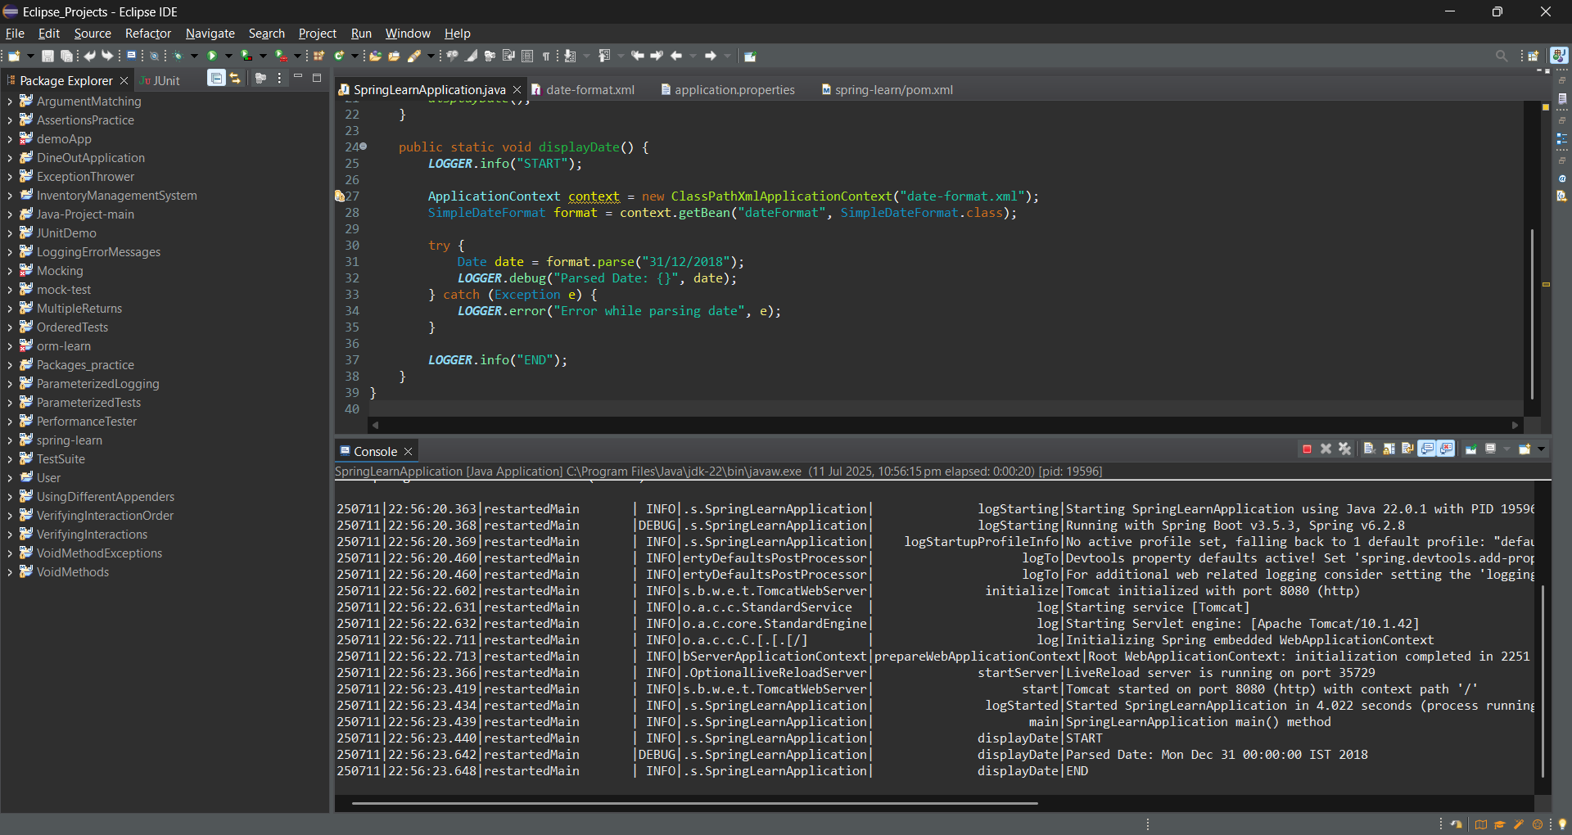

**Hands on 4**

**Spring Core – Load Country from Spring Configuration XML**   
**SpringLearnApplicatoin.java**

package com.cognizant.spring_learn;

import org.slf4j.Logger;

import org.slf4j.LoggerFactory;

import org.springframework.boot.SpringApplication;

import org.springframework.boot.autoconfigure.SpringBootApplication;

import org.springframework.context.ApplicationContext;

import org.springframework.context.support.ClassPathXmlApplicationContext;

@SpringBootApplication

public class SpringLearnApplication {

private static final Logger LOGGER = LoggerFactory.getLogger(SpringLearnApplication.class);

public static void main(String[] args) {

SpringApplication.run(SpringLearnApplication.class, args);

LOGGER.info("SpringLearnApplication main() method");

displayCountry();

}

public static void displayCountry() {

LOGGER.info("START");

ApplicationContext context = new ClassPathXmlApplicationContext("country.xml");

Country country = context.getBean("country", Country.class);

LOGGER.debug("Country : {}", country.toString());

LOGGER.info("END");

}

}

**Country.java**

package com.cognizant.spring_learn;

import org.slf4j.Logger;

import org.slf4j.LoggerFactory;

public class Country {

private static final Logger LOGGER = LoggerFactory.getLogger(Country.class);

private String code;

private String name;

public Country() {

LOGGER.debug("Inside Country Constructor.");

}

public String getCode() {

LOGGER.debug("getCode() called");

return code;

}

public void setCode(String code) {

LOGGER.debug("setCode() called");

this.code = code;

}

public String getName() {

LOGGER.debug("getName() called");

return name;

}

public void setName(String name) {

LOGGER.debug("setName() called");

this.name = name;

}

@Override

public String toString() {

return "Country [code=" + code + ", name=" + name + "]";

}

}

**Country.xml**

<?xml version="1.0" encoding="UTF-8"?>

<beans xmlns="http://www.springframework.org/schema/beans"

xmlns:xsi="http://www.w3.org/2001/XMLSchema-instance"

xsi:schemaLocation="http://www.springframework.org/schema/beans

https://www.springframework.org/schema/beans/spring-beans.xsd">

<bean id="country" class="com.cognizant.spring_learn.Country">

<property name="code" value="IN" />

<property name="name" value="India" />

</bean>

</beans>

**Output:**

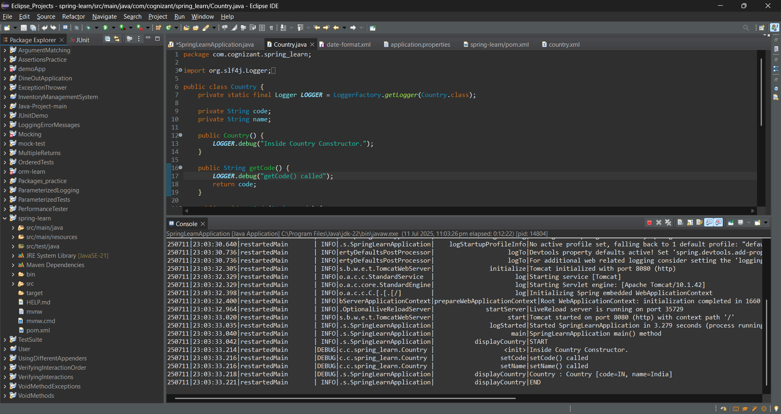

**Hands on 5**

**Spring Core – Demonstration of Singleton Scope and Prototype Scope**   
  
**SpringLearnApplication.java**

package com.cognizant.spring_learn;

import org.slf4j.Logger;

import org.slf4j.LoggerFactory;

import org.springframework.boot.SpringApplication;

import org.springframework.boot.autoconfigure.SpringBootApplication;

import org.springframework.context.ApplicationContext;

import org.springframework.context.support.ClassPathXmlApplicationContext;

@SpringBootApplication

public class SpringLearnApplication {

private static final Logger LOGGER = LoggerFactory.getLogger(SpringLearnApplication.class);

public static void main(String[] args) {

SpringApplication.run(SpringLearnApplication.class, args);

LOGGER.info("SpringLearnApplication main() method");

displayCountry();

}

public static void displayCountry() {

LOGGER.info("START");

ApplicationContext context = new ClassPathXmlApplicationContext("country.xml");

Country country1 = context.getBean("country", Country.class);

Country country2 = context.getBean("country", Country.class);

LOGGER.debug("Country 1 : {}", country1);

LOGGER.debug("Country 2 : {}", country2);

LOGGER.info("Are both country objects same? : {}", country1 == country2);

LOGGER.info("END");

}

}

**Country.xml**

<?xml version="1.0" encoding="UTF-8"?>

<beans xmlns="http://www.springframework.org/schema/beans"

xmlns:xsi="http://www.w3.org/2001/XMLSchema-instance"

xsi:schemaLocation="http://www.springframework.org/schema/beans

https://www.springframework.org/schema/beans/spring-beans.xsd">

<bean id="country" class="com.cognizant.spring_learn.Country">

<property name="code" value="IN" />

<property name="name" value="India" />

</bean>

</beans>

**Output:**

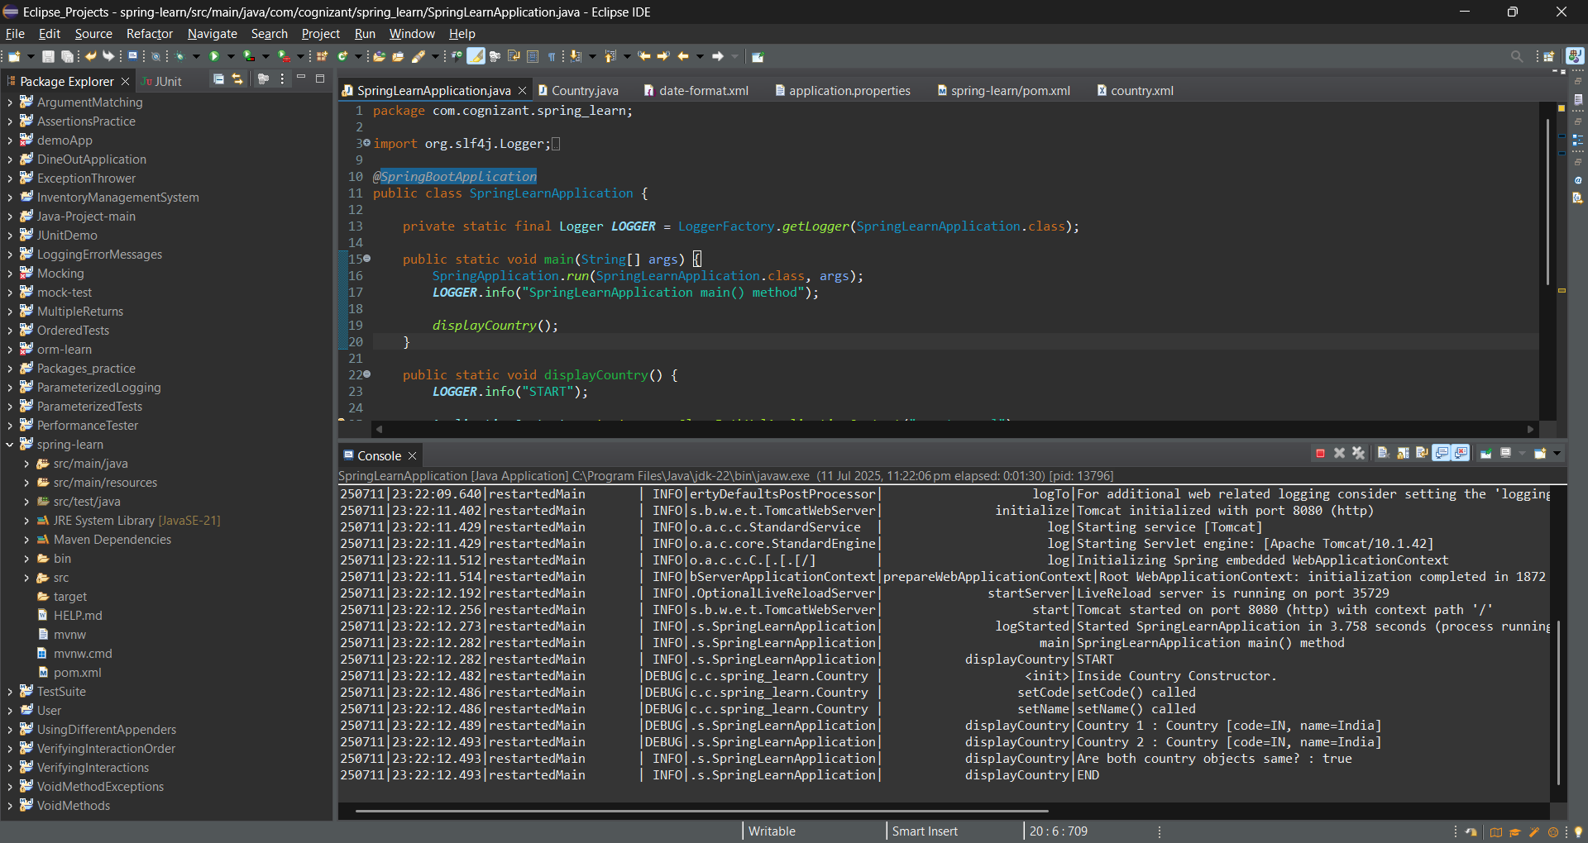

**Hands on 6**

**Spring Core – Load list of countries from Spring Configuration XML** 

**SpringLearnApplication.java**

package com.cognizant.spring_learn;

import java.util.List;

import org.slf4j.Logger;

import org.slf4j.LoggerFactory;

import org.springframework.boot.SpringApplication;

import org.springframework.boot.autoconfigure.SpringBootApplication;

import org.springframework.context.ApplicationContext;

import org.springframework.context.support.ClassPathXmlApplicationContext;

@SpringBootApplication

public class SpringLearnApplication {

private static final Logger LOGGER = LoggerFactory.getLogger(SpringLearnApplication.class);

public static void main(String[] args) {

SpringApplication.run(SpringLearnApplication.class, args);

LOGGER.info("SpringLearnApplication main() method");

displayCountry();

}

public static void displayCountry() {

LOGGER.info("START");

ApplicationContext context = new ClassPathXmlApplicationContext("country.xml");

@SuppressWarnings("unchecked")

List<Country> countryList = (List<Country>) context.getBean("countryList");

LOGGER.debug("Country List: {}", countryList);

LOGGER.info("END");

}

}

**Country.xml**

<?xml version="1.0" encoding="UTF-8"?>

<beans xmlns="http://www.springframework.org/schema/beans"

xmlns:xsi="http://www.w3.org/2001/XMLSchema-instance"

xsi:schemaLocation="http://www.springframework.org/schema/beans

https://www.springframework.org/schema/beans/spring-beans.xsd">

<bean id="in" class="com.cognizant.spring_learn.Country">

<property name="code" value="IN" />

<property name="name" value="India" />

</bean>

<bean id="us" class="com.cognizant.spring_learn.Country">

<property name="code" value="US" />

<property name="name" value="United States" />

</bean>

<bean id="de" class="com.cognizant.spring_learn.Country">

<property name="code" value="DE" />

<property name="name" value="Germany" />

</bean>

<bean id="jp" class="com.cognizant.spring_learn.Country">

<property name="code" value="JP" />

<property name="name" value="Japan" />

</bean>

<!-- List of countries -->

<bean id="countryList" class="java.util.ArrayList">

<constructor-arg>

<list>

<ref bean="in"/>

<ref bean="us"/>

<ref bean="de"/>

<ref bean="jp"/>

</list>

</constructor-arg>

</bean>

</beans>

**Output:**

